An-Najah National University
Faculty of Engineering and IT
Course: Cryptography

Man-in-The-Middle Attacks and Prevention

Student Name: Ahmed Mohamed Sabri Abusaliqa
Student ID : 12429345

Instructor: Dr. Jihad Hamamra

9/4/2026

Introduction:
In today’s digital world, network security has become a critical concern due to the increasing number of cyberattacks targeting users and systems. One of the most dangerous types of attacks is the Man-in-the-Middle (MITM) attack, where an attacker intercepts and potentially alters communication between two parties without their knowledge.
This project explores several types of MITM attacks, including ARP spoofing, DNS spoofing, Evil Twin, SSL stripping, and MITM Proxy. These attacks exploit weaknesses in network security to gain unauthorized access to sensitive data.
The main problem addressed in this project is the vulnerability of networks, whether wired, wireless, or cellular, to such attacks. Therefore, this research also focuses on methods of preventing these attacks and improving overall network security.

Overview of MITM
A Man-in-the-Middle (MITM) attack is a cyberattack where an attacker secretly relays and possibly alters communications between two parties.
MITM ex – Active Eavesdropping:
- Attacker makes independent connections with both victims.
- Victims think they are communicating privately, but the attacker controls the communication.
- Works easily on unencrypted Wi-Fi networks.
MITM aims to circumvent mutual authentication.
MITM attack can succeed only when the attacker impersonates each endpoint sufficiently.
Most cryptographic protocols include some form of endpoint authentication specifically to prevent MITM attack
- Ex: TLS can authenticate one or more both parties using a mutually trusted certificate authority.
MITM ex – key Replacement attack:
- Alice wants to communicate with Bob.
- Mallory intercepts message and replaces Bob’s key with her own.
- Alice encrypts message with Mallory’s key Mallory can read/modify it.
- Mallory re-encrypts it with Bob’s key and forwards it Bob thinks it’s secure.
- Shows importance of verifying public keys to prevent MITM.
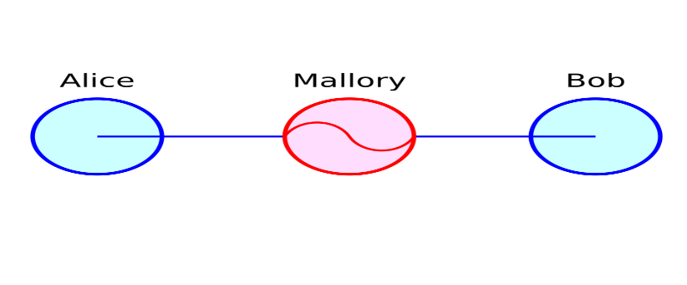
Types of MITM:
In this section, we will mention some types of MITM attacks, their definitions, how they work, and their effects during attack Implementation.

- ARP Spoofing:
ARP Protocol: Address Resolution Protocol (ARP) is a protocol that enables network communications to reach a specific device on the network ARP translates (IP) addresses to (MAC) address.

ARP Spoofing: also known as ARP Poisoning, is a Man-in-the-Middle (MITM) attack that allows attackers to intercept communicate between network devices.

How it Works:
- The attacker must have access to the network; they scan the network determine the IP addresses of at least two devices.
- The attacker uses a Spoofing tool, to send out forged ARP responses.
- The forged responses advertise that the correct MAC addresses, belong to the two devices, is the attacker’s MAC address, This fools both devices to connect to the attacker’s devices, instead of to each other.
- The two devices update their ARP cache and from that point onwards, communicate with the attacker instead each other.
- The attacker is now secretly in the middle of all communications.
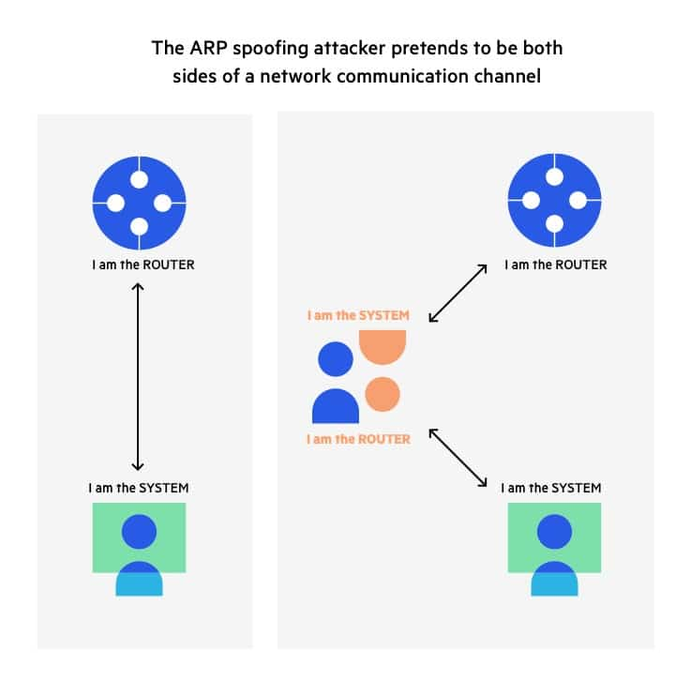
Tools Used: Kali Linux, Ettercap, Bettercap.

Implementation:
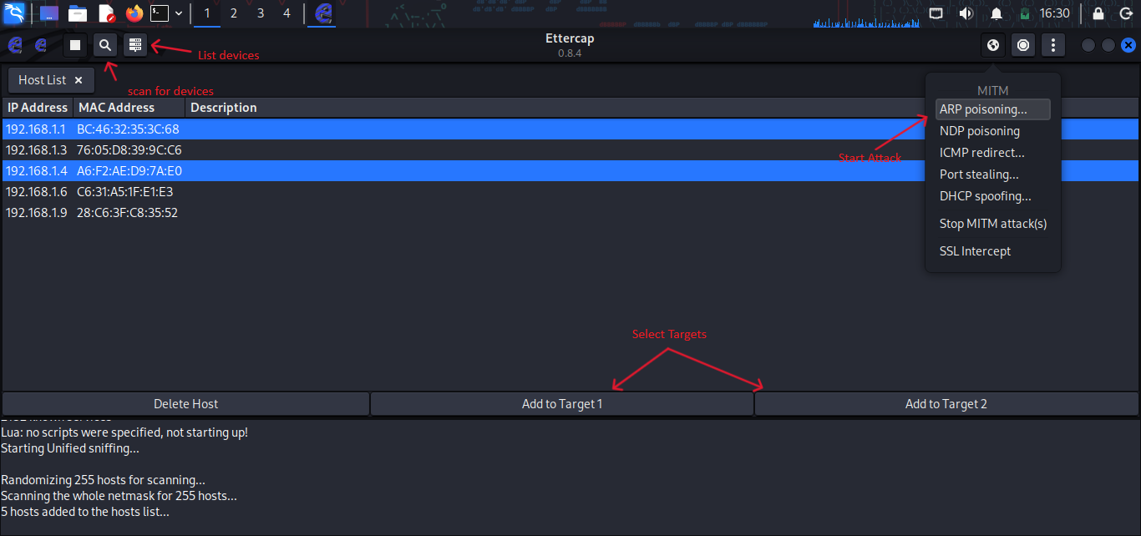
First, we need network access and a Wi-Fi adapter that supports Managed to route data traffic. Then, we open one of the tools; in our example, Ettercap on Kali Linux.
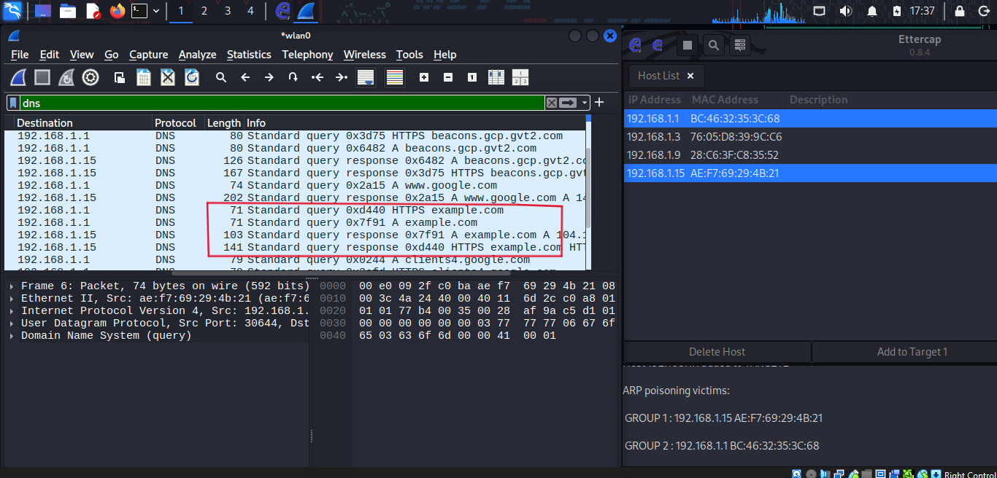
After the attack was carried out, one of the sites was opened for testing, and as we can see, our traffic was redirected.

Once the attacker succeeds in an ARP Spoofing attack, they can:
- Continue routing the communication as is – the attacker can sniff the packets and steal data, except if it is transferred over an encrypted channel like HTTPS
- Perform session hijacking – if the attacker obtains a session IP, they can gain access to accounts the user is currently logged into.
- Alter communication – for example pushing a malicious file or website to workstation.
- Distributed Denial of Service (DDoS) – the attacker can provide the MAC address of a server they wish to attacker with DDoS instead of their own machine.

- DNS Spoofing:
Normal DNS:
- The user requests a website on their device.
- The DNS resolver (usually run by the ISP) receives the query.
- If the resolver does not have the IP in cached, it queries a root server.
- The root server directs the resolver to the appropriate Top – Level Domain (TLD) server (ex: .com, .org, .net).
- The TLD server points the resolver to the domain’s authoritative name sever.
- The authoritative server returns the IP address to the resolver.
- The resolver provides the IP address to the user’s device, allowing connection to the website.

DNS Spoofing: Domain Name Server (DNS) Spoofing, or DNS cache Poisoning, is an attacker involving manipulating DNS records to redirect users toward a fraudulent, malicious website that may resemble the user’s intended destination.

How it works:
DNS Spoofing Works by exploiting flaws in the DNS and its associated protocols, ways:
- A malicious actor may use (ARP) to access router traffic and alter the DNS records.
- The attacker can modify an authoritative DNS server’s records traffic to the fraudulent website.
- The attacker can target an intermediate name server and exploit weaknesses in its caching system to perform a (MITM) attack.
DNS Spoofing attack methods:
- Man-in-the-Middle (MITM): This method involves intercepting communication between users and a DNS server to redirect them to different or malicious IP address.
- DNS server Compromise: This method, attackers hijacking DNS server configured to return a malicious IP address.
- Exploiting Time-To-Live (TTL): This method exploits the DNS server cache’s Time-To-Live (TTL) values, Attackers manipulate the TTL values to ensure incorrect DNS entries Persist for longer periods.

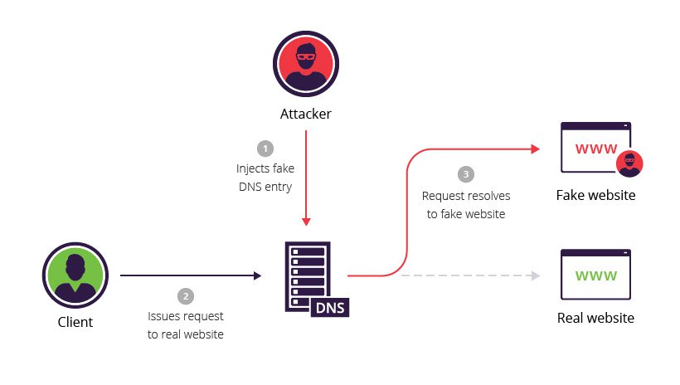
Tools used: Kali Linux, Ettercap, Bettercap.

Implementation: 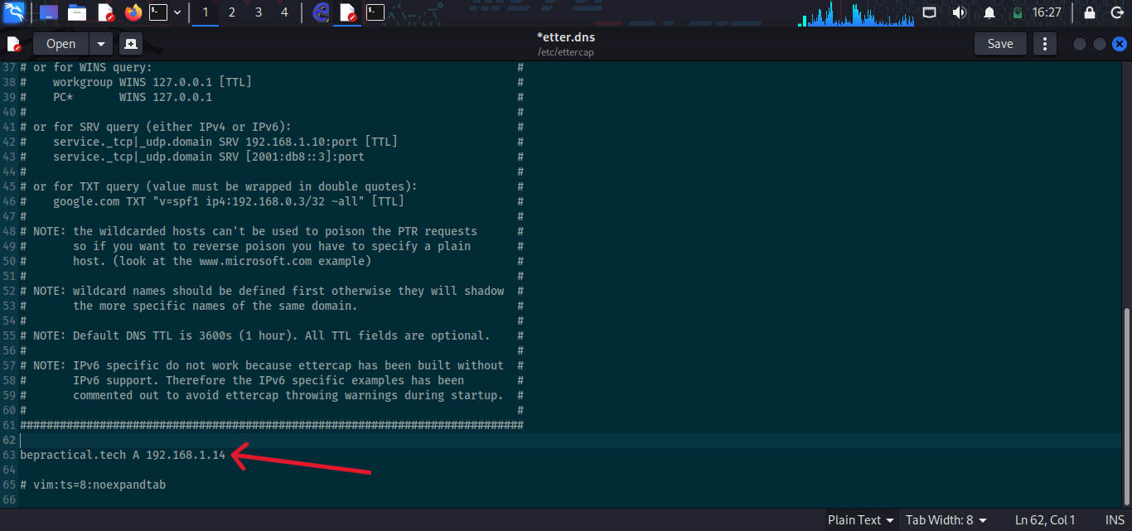
First, we need a network connection and a Wi-Fi adapter that supports network management to route data traffic. We must add the following to the file (/etc/ettercap/etter.dns): the site we want to redirect to ("Original Site" A, Site to Redirect To").

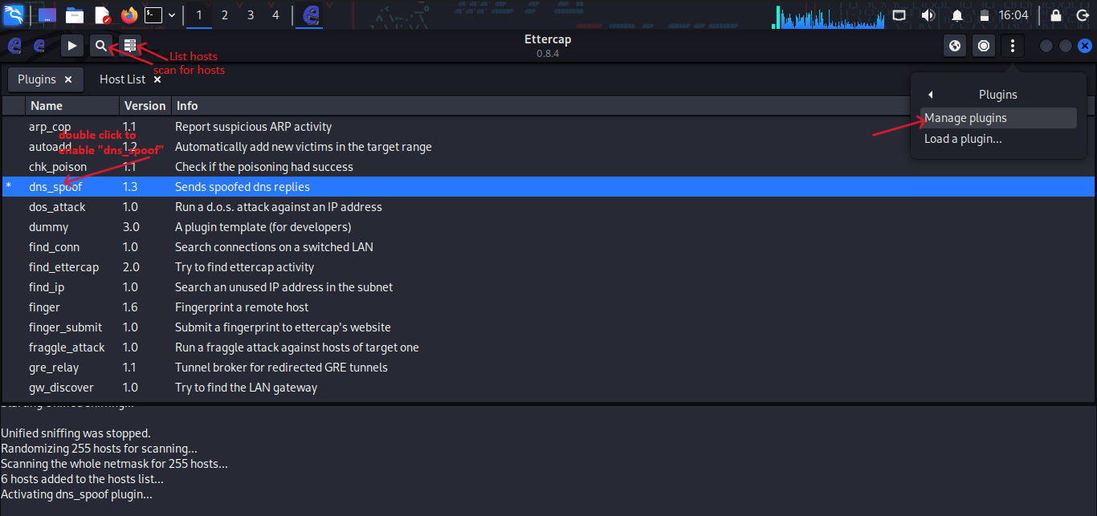
Then we go to the ettercap tool in our example and go to "Manage plugins" and enable "dns_spoof".

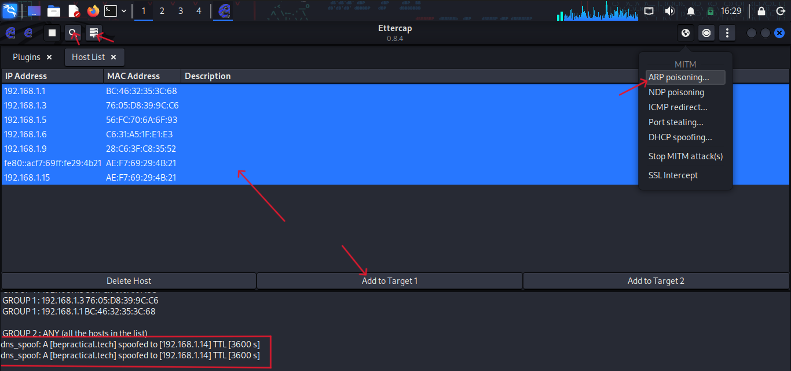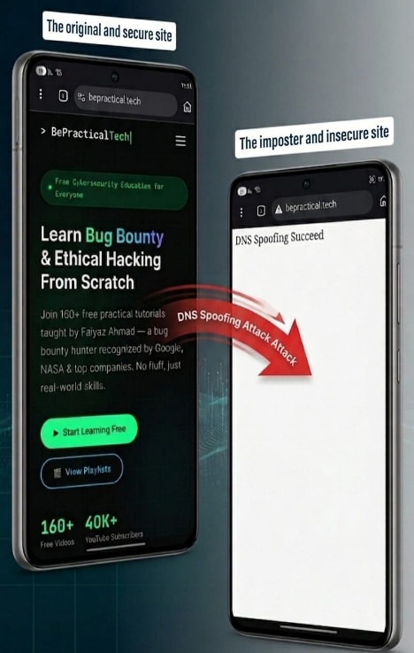
Then we perform an "ARP Spoofing" attack, and as we can see, upon entering the site specified in the file, it is redirected.

Once the attacker succeeds in an DNS Spoofing attack, they can:
- Attacker can steal access credentials or other sensitive information.
- The fraudulent website can install worms or viruses on the user’s computer secretively.
- Giving the attacker sustained access to the user’s device and data.

- Wi-Fi MITM (Evil Twin):
Evil Twin: An evil twin attack occurs when an attacker creates a fake Wi-Fi access point to trick users into connecting instead of a legitimate network.

How it works:
- Looking for the right location: Attackers typically look for busy locations with free, popular Wi-Fi.
- Setting up a Wi-Fi access point: The Attackers then takes note of the legitimate network’s service set Identifier (SSID) and sets up a new account with the same name SSID, they can use almost any device to do this.
- Encouraging victims to connect to the evil twin Wi-Fi.
- Setting up fake captive portal: The attacker creates a fake Wi-Fi login page to trick users.
- Stealing victim’s data: Anyone who logs in connects via the attacker this is classic MITM attack that allows the attacker to monitor the victim’s online activity.

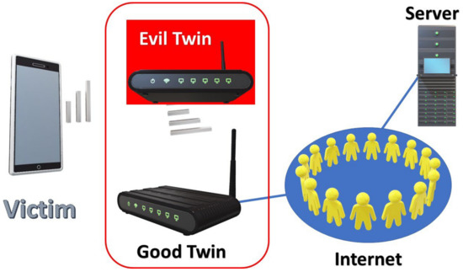

Tools used: Kali Linux, Airgeddon, Airbase-ng (crate fake wifi), airodump-ng (for known SSID).

Implementation:
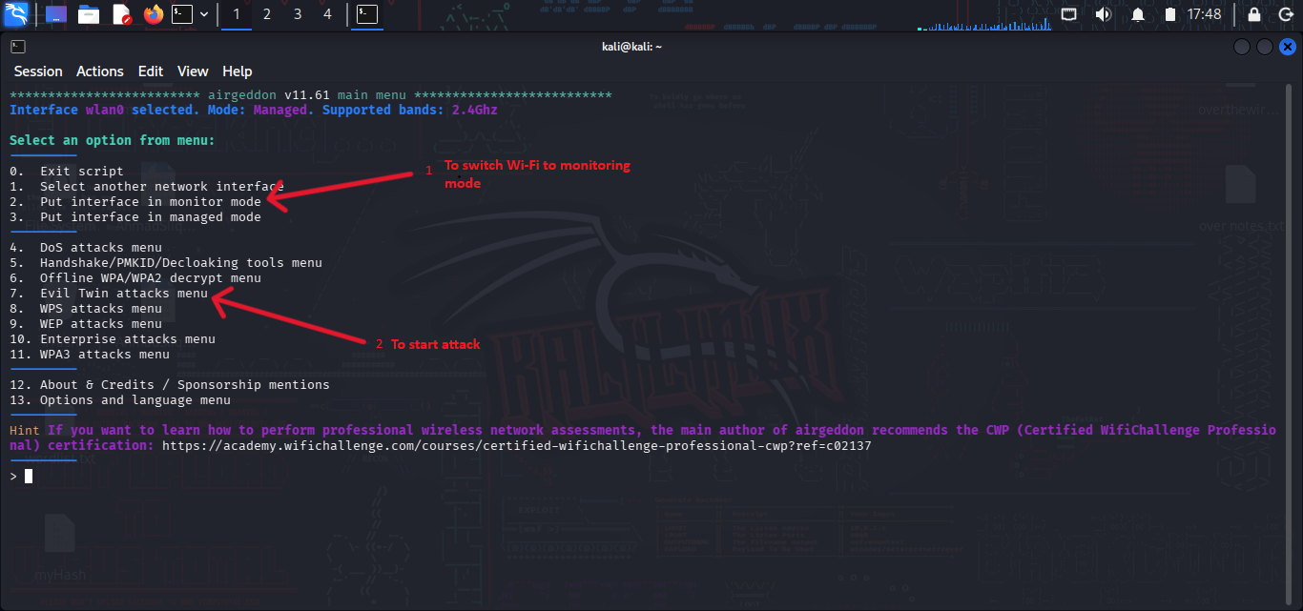
First, we need a Wi-Fi adapter that supports network monitoring to search for available networks. In our example, we open the "airgeddon" tool and use it to switch the Wi-Fi to monitoring mode and start the attack.
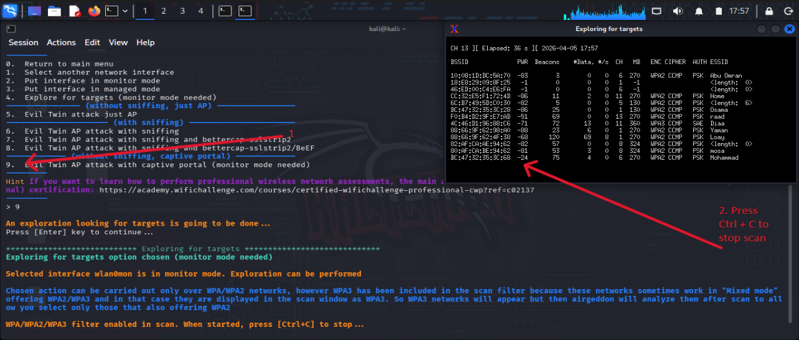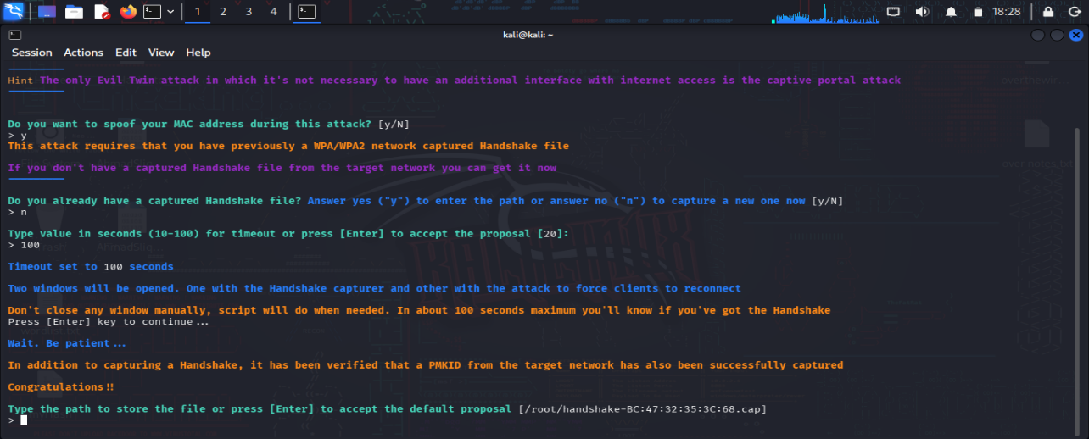
Then we select the network and follow the tool's instructions to set up the attack.
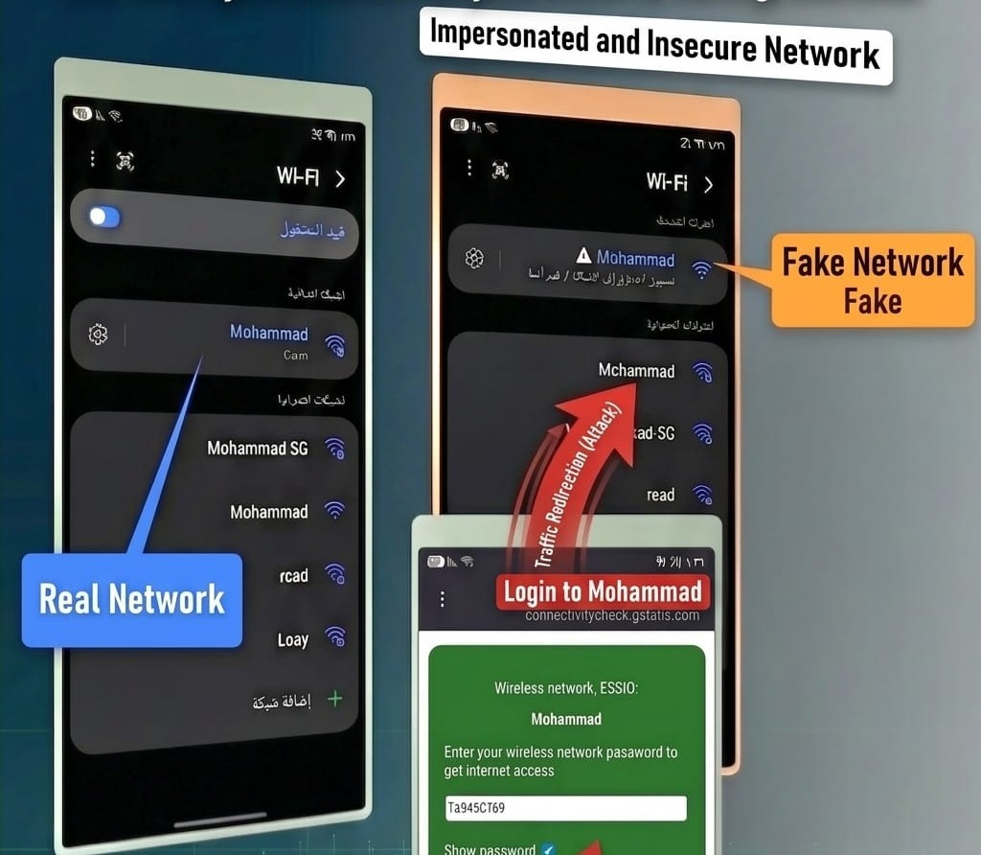
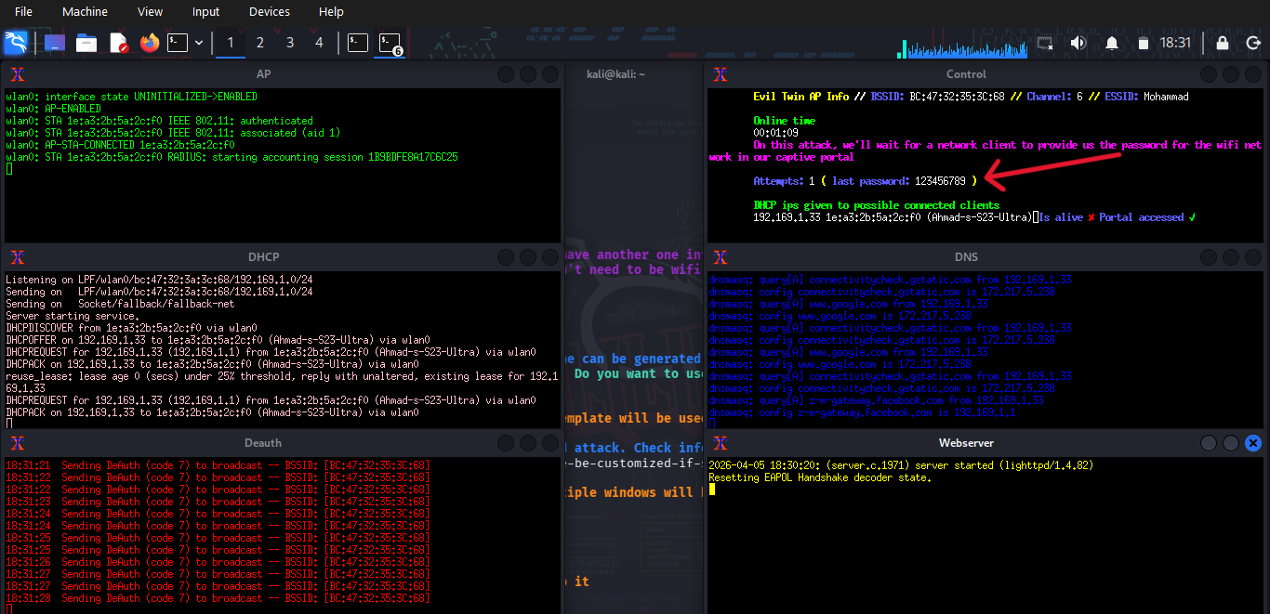
As we can see, the real and fake networks are present. Upon entering the fake network, a login page opens requiring a password. When the password is entered, it appears to the attacker, and if the password is correct, the victim is redirected to the real network.

Once the attacker succeeds in an Evil Twin attack, they can:
- Steal login credentials and other private information.
- Attacker could also insert malware into your device.
- Evil twin Wi-Fi attacks often don’t leave tell-tale sings which could expose their true nature, they perform their primary task of providing access to the internet.

- SSL/TLS Stripping:
SSL/TLS: TLS is what keeps internet communication secure, it encrypts the data sent over HTTPS, protecting its confidently, authenticity, and integrity, unlike HTTP, which sends data in plain text, HTTPS adds an encryption layer.
SSL/TLS Stripping: Is a type of (MITM) attack that downgrades secure HTTPS connections to less secure HTTP, by removing the encryption provided by TLS (Transport Layer Security).
How it works:
- Attacker gains Position in the Network: The attacker gains access to the network and positions themselves as an intermediary between the victim and the server, this can be achieved through: ARP Spoofing, DNS Spoofing
- Interception of HTTPS requests: The attacker intercepts the victim’s HTTPS requests and alters them. They downgrade the secure HTTPS connections requests to encrypted HTTP connection. The attacker then relays traffic between the victim and the server.
- Relaying unencrypted traffic: The victim’s browser loads the website using HTTP instead of HTTPS, unknowingly, the user sends sensitive information -such as username, passwords- in plain text.
- Data Theft and Exploitation: The Attacker collects this unsecured data for exploitation, theft information, or injection malicious code execute further attacks.
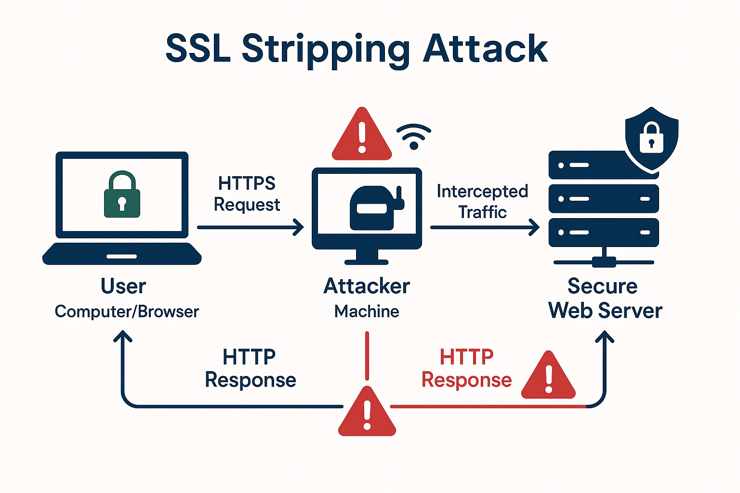
Tools used: Kali Linux, Ettercap, Bettercap, sslstrip.

Implementation:
First, we need a network connection and a Wi-Fi adapter that supports network management to route data traffic. In our example, we used the “bettercap” tool we run it and enter the following commands: “set http.proxy.sslstrip true” and “hstshijack/hstshijack” to activate the attack.

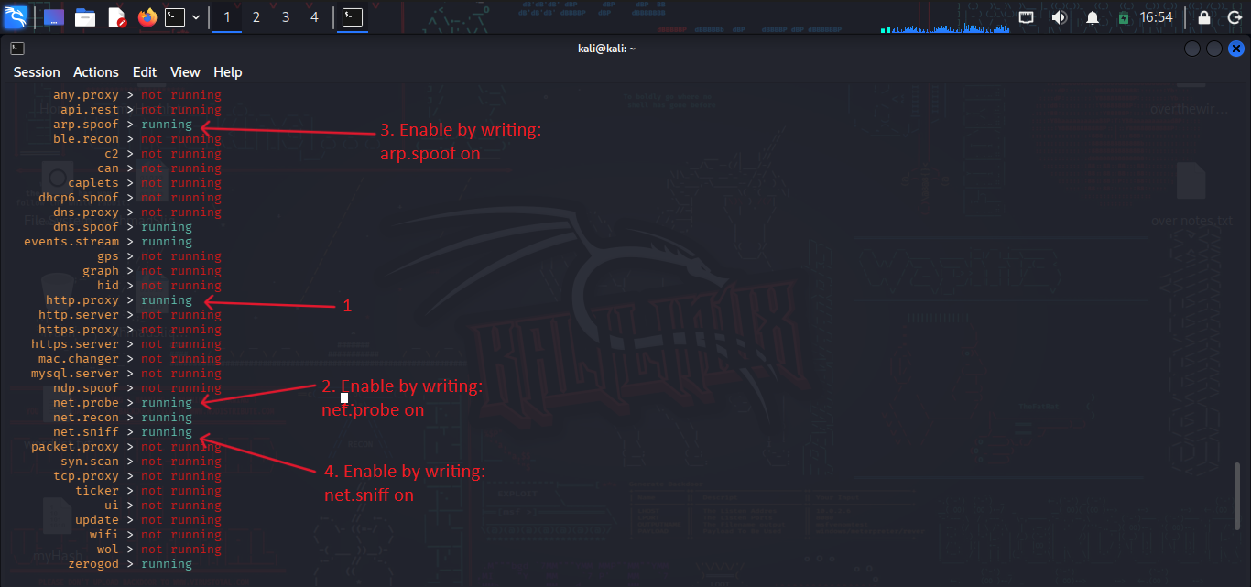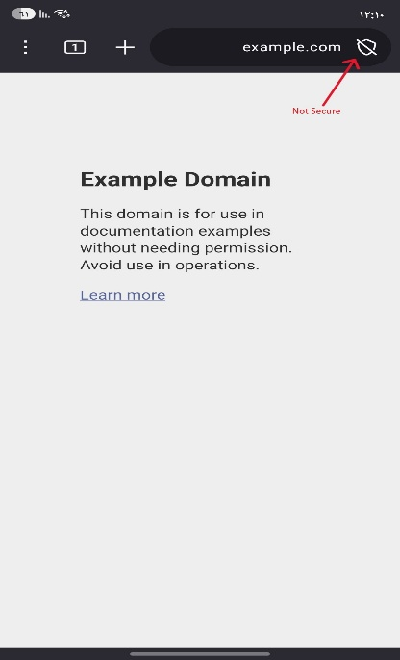
We perform the following services, and as we can see, when we enter one of the sites We find that it is not secure because we are redirected to the HTTP protocol.

Once the attacker succeeds in an SSL/TLS Stripping attack, they can:
- Stealing sensitive information.
- Intercepting and modifying data.
- Breaking secure communicate.

- MITM Proxy:
A proxy-based MITM attack is a technique where an attacker intercepts network traffic by routing it through a proxy server. This allows the attacker to monitor and analyze communication, even on mobile (cellular-like) environments.

How it works:
- The attacker sets up a proxy server on their device.
- The victim routes traffic through the proxy.
- The proxy intercepts requests and responses.
- The attacker can monitor or analyze the data
Tools used: Kali Linux, Burp Suite.
Implementation:
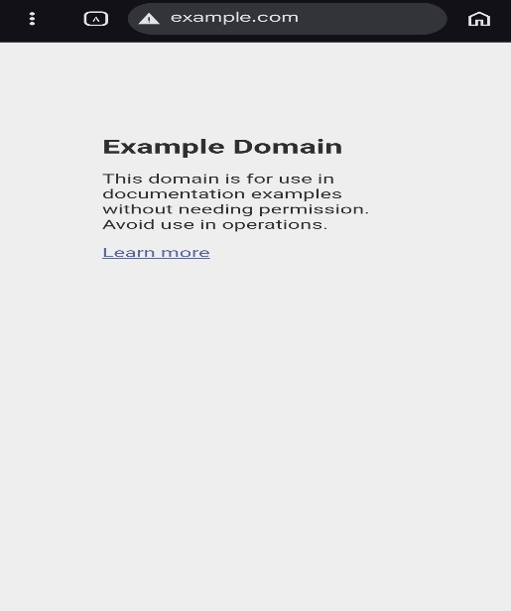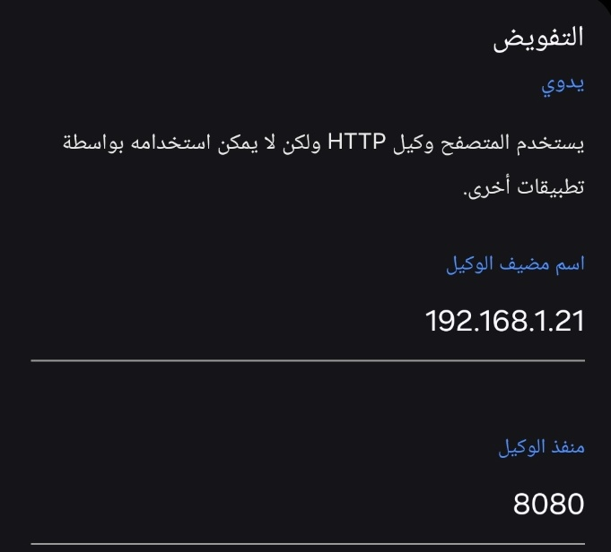
First, we configure the proxy settings on the victim's device.
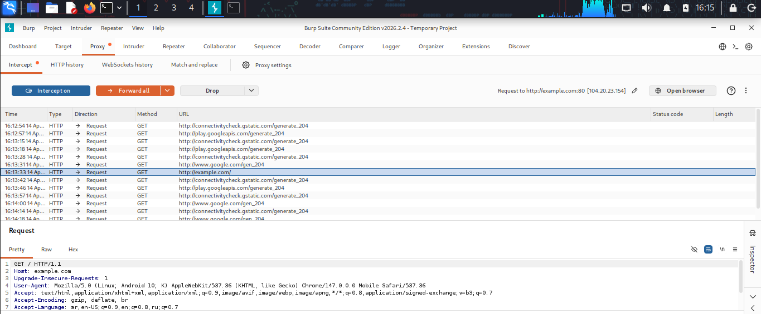
In our example, we used the "Burp Suite" tool, and when creating the proxy server, we see that the traffic on the victim's machine passes through the tool.

Once the attacker succeeds in an MTM Proxy attack, they can:
- Attacker can monitor network traffic.
- Sensitive data may be exposed.
- User activity can be analyzed.
MITM Prevention:
In this section, we will study methods of preventing some of the MITM attacks we mentioned.

- ARP Spoofing Prevention:
- Use a Virtual Private Network (VPN): a VPN allows devices to connect to the internet through an encrypted tunnel. This makes all communication encrypted, and worthless for an ARP Spoofing attacker.
- Use static ARP: The ARP protocol lets you define a static ARP entry for an IP address, and prevent devices from listening on ARP responses for that address.
- Use packet filtering: packet filtering solutions can identify poisoned ARP packets by seeing that they contain conflicting source information and stop them before they reach devices on your network.
- Run a Spoofing attack: Check if your existing defenses are working by mounting a spoofing attack, in coordination with IT and security teams, if the attack succeeds, identify weak points in your defensive measures and remediate them.

- DNS Spoofing Prevention:
- Domain Name System Security Extensions (DNSSEC): DNSSEC is a suite of specifications for securing certain kinds of information provided by DNS, it gives origin authenticated of DNS data, data integrity, and authenticated denial of existence. DNSSEC does not provide confidentiality of data; all DNSSEC response are authenticated but not encrypted.
- Use Trusted DNS server: using a trustworthy DNS server can safeguard against DNS Spoofing. These servers have highly secure and regularly update systems that are less likely to be compromised.
- Cryptographically secured communications: cryptographically secure your communications with DNS servers using protocols like DNSCrypt. This ensure that the responses are from a trusted source and have not been tampered.
- Regular System updates: periodic system updates can protect against many types attacks keeping DNS software up-to-date ensure the latest security patches are in place.
- Network Security measures: Implementing network security measure like web application firewalls (WAF), intrusion detection systems (IDS), or intrusion prevention system (IPS) can help identify and block potential DNS Spoofing attacks.
- IPSec (Internet Protocol Security): IPSec uses cryptographic security services to protect communication over IP network. It enhances and secures data flow between the host and network, or between networks.

- Wi-Fi MITM (Evil Twin) Prevention:
- Avoid unsecured Wi-Fi: Avoid connecting to open or unsecured networks, as they are often unsafe.
- Use your own Hotspot: Use your personal hotspot instead of public Wi-Fi to stay secure.
- Pay Attention to warning: Do not ignore security warnings from your device.
- Disable auto-connect: Turn off auto-connect to prevent connecting to fake network automatically.
- Avoid Sensitive logins: Do not log into important accounts on public Wi-Fi.
- Use multi-Factor Authentication: Enable extra verification (like a code) for better account security.
- Use HTTPS websites: Always use secure websites that start with HTTPS.
- Use a VPN: A VPN encrypts your data and protects you from attackers.

- SSL/TLS Stripping prevention:
- Implementing HSTS (HTTP Strict Transport Security): HSTS enforces secure HTTPS communication by allowing browsers to remember and automatically apply a strict “HTTPS only” policy when revisiting a website.
- Using secure HTTPS configurations:
- Enable HTTPS redirects on your web server to automatically upgrade HTTP requests.
- Disable weak encryption protocols that attackers might use as an entry point.
- Network security measures:
- Enable Secure DNS (DoH): Encrypt DNS queries to thwart DNS Spoofing attacks.
- Monitor ARP and DNS Tables: use tools to flag suspicious changes that may indicate active MITM attacks.

- MITM Proxy prevention:
- Use HTTPS connections.
- Avoid untrusted proxy settings.
- Use VPN.
- Do not install unknown certificates.

Conclusion:
In conclusion, this project explored several types of Man-in-the-Middle (MITM) attacks, including ARP spoofing, DNS spoofing, Evil Twin, SSL stripping, and MITM Proxy. These attacks demonstrate how attackers can exploit weaknesses in network security to intercept and manipulate communication between users.
The practical implementation of these attacks highlighted the real risks that exist in both wired and wireless networks, including Wi-Fi and cellular environments. It became clear that unsecured networks and improper configurations can make systems vulnerable to such threats.
Therefore, applying proper prevention techniques such as encryption, secure protocols, and network monitoring is essential to protect users and ensure secure communication. This project emphasizes the importance of cybersecurity awareness and the need to follow best practices to reduce the risk of these attacks.

References:

- Wikipedia{MITM Attack}{ https://en.wikipedia.org/wiki/Man-in-the-middle_attack}
- Imperva {ARP Spoofing} { https://www.imperva.com/learn/application-security/arp-spoofing/ }
- Imperva {DNS Spoofing } {https://www.imperva.com/learn/application-security/dns-spoofing/ }
- Kaspersky {Evil Twin } { https://www.kaspersky.com/resource-center/preemptive-safety/evil-twin-attacks }
- Jumpcloud { SSL/TLS Stripping} { https://jumpcloud.com/it-index/what-is-ssl-tls-stripping }
- Youtube: {ARP Poisoning}{ https://www.youtube.com/watch?v=A7nih6SANYs&t=502s }
  - {Evil Twin Attack}{ https://www.youtube.com/watch?v=chgfc3d9XJs&t=21s }
  - {DNS Spoofing}{ https://www.youtube.com/watch?v=mKRCxIz3lhc }
  - {SSLSTRIP}{ https://www.youtube.com/watch?v=Peu0AEpHUVs&t=388s }

